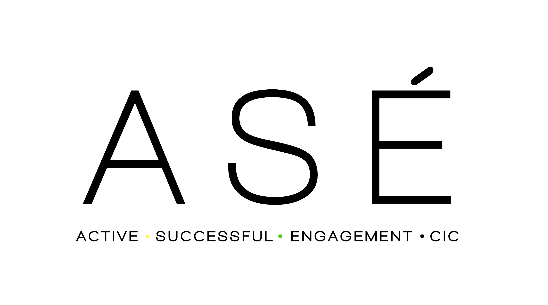
i-MATTER MENTORING PROGRAMME
Recommendation Form

Please complete all pages and return to: Paulinezepherin@asecic.org.uk
DETAILS OF ORGANISATION MAKING A RECOMMENDATION

Recommending Organisation | Please ignore this section
Name
Position
Address
Postcode
Telephone number
Email
In what capacity do you know the applicant?
How long have/will you be working with the applicant?
Are there any other organisations working with the Applicant?

APPLICANT’S DETAILS

Name
Address
Postcode
Phone Number
Email
Age
Date of Birth
Ethnicity

PARENT/CARER DETAILS (if applicable)

Name
Relationship to the Applicant
Address
Postcode
Parent/Carer Phone Number/s (if applicable)
Parent/Carer Email (if applicable)
EDUCATION OR EMPLOYMENT DETAILS

Does the applicant attend: | School/College/Employment/Other (delete as applicable)
Name of school/college/company/other
Name of link staff member (if applicable)
Phone Number
Email
Any additional support

RECOMMENDATION CRITERIA

Applicants must be 13-18 years old (up to 25 years with SEND) and Adults with children. They must give your their consent and be interested in being mentored. They must live in London Borough of Hammersmith and Fulham.

REASONS FOR RECOMMENDATION

What are the reasons for the Recommendation?

Please complete reasons within the following areas.
In answering this question reference any risk factors, expanding each box as required.
If the answer is to any of the following questions, please give details:

Health History  Does your client have a disability?  If Yes, please give details: | Yes / No
Does your client have a health condition which is relevant to your Recommendation?  If Yes, please give details: | Yes / No
Is your client on any medication?  If yes, please give details: | Yes / No
Are there any special facilities or requirements we need to be aware of to support your client to attend an interview/ sessions?
Any history of violence  alcohol/substance misuse  If yes, please give details: | Yes / No  Yes / No
Any history of mental health issues?  If yes, please give details: | Yes / No
Any history of self-harm / self-injuries | Yes / No  Details and date of most recent:
Any history of Suicidal ideation? | Yes / No  Details:
Any history of Suicide attempts? | Yes / No Accidental / Deliberate  Details and date of last attempt:
Please provide brief overview of

Wider Family:

Peers:

Social /Educational Factors:

If yes, please give details:

Details of other agencies involved or referrals made

Criminal Convictions
Does your client have any criminal convictions?  If Yes, please provide details | Yes / No
Are there any current criminal conviction proceedings?  If Yes, please provide details | Yes / No
If the applicant has been cautioned by the police or entered the Youth Justice System please detail here.

What are your aims and objectives in terms of recommending your client to our programme?

I have agreed to share the above personal information, including any offending behaviour history, with Active Successful Engagement (ASÉ) CIC and their partner agencies, and understand that in giving this information, it will be treated in the strictest confidence.

Signature of Applicant: Date:

Signature of Parent/ Carer: Date:

(Note: Verbal agreement from parent/carer is acceptable. If the Recommendation is accepted, a separate consent form will be sent to the parent/ carer if they are the person Recommending the mentee to the mentoring programme)

THANK YOU
We will contact the person making the Recommendation within two weeks of receiving the Recommendation Form to confirm next steps

Please return completed forms to: paulinezepherin@asecic.org.uk
OR
Active Successful Engagement CIC
Registered Office: 15 Stilecroft Gardens
Wembley, Middx HA0 3HE
Website: www.asecic.org.uk
Main Office No: 0208 058 1996

